

FACULTY OF COMPUTING AND TECHNOLOGY
UNIVERSITY OF KELANIYA

Introduction To Program Components
Lab Worksheet - 01

Student Name : M.A.L.Dilshani
Student Number : CT/2022/065

INTRODUCTION :

This report is based on Object-Oriented Programming (OOP) concepts using Java, and its main purpose is to understand basic program components such as creating graphical user interfaces (GUI) using frames, taking user input, working with strings, and displaying date and time. These activities help to learn how a program works by combining input, processing, and output, and they are important for developing simple and real-world software applications.

DESCRIPTION OF THE LAB ACTIVITIES :

This lab worksheet includes several Java programs that demonstrate basic programming components. We created graphical user interfaces using JFrame, took user input using JOptionPane and Scanner, and performed string operations such as finding length and extracting characters. We also displayed current date and time using Java libraries. These activities helped to understand how input, processing, and output work together in a program.

IMPLEMENTATION :

Question 01:

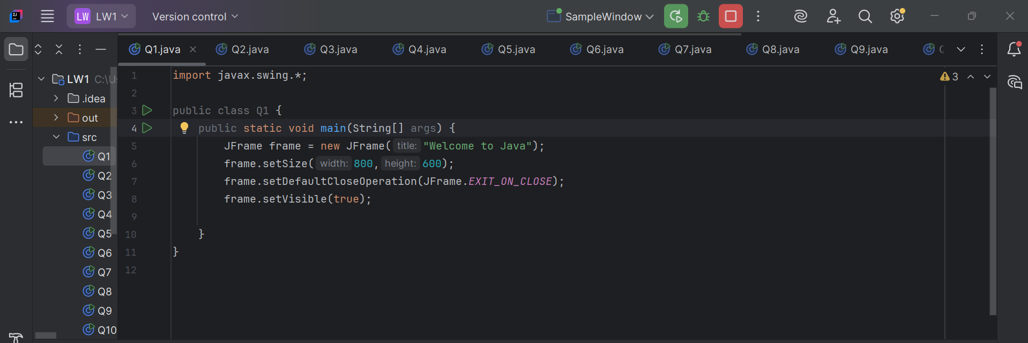
Output :

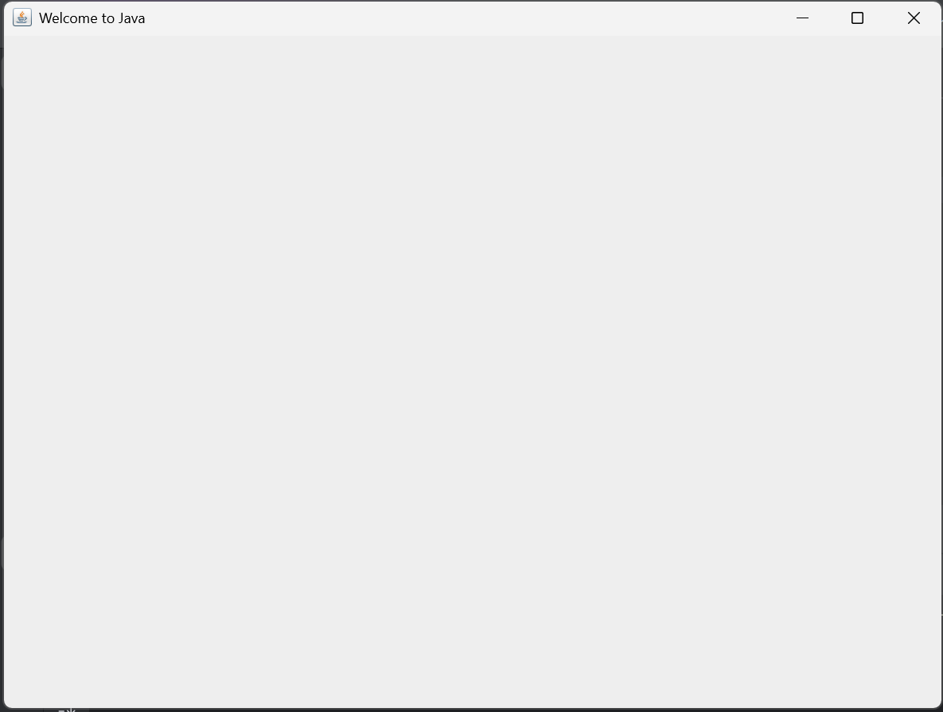
Question 02:

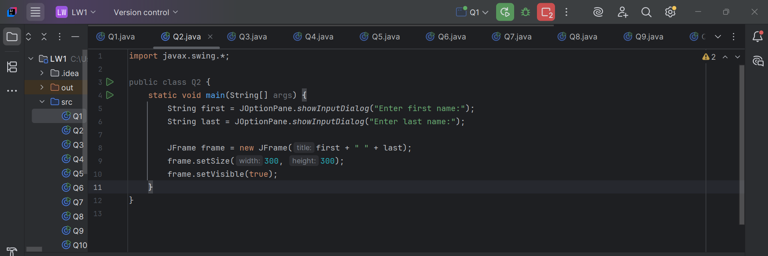

Output :

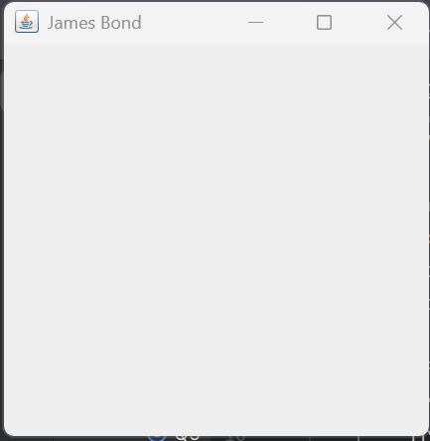

Question 03:

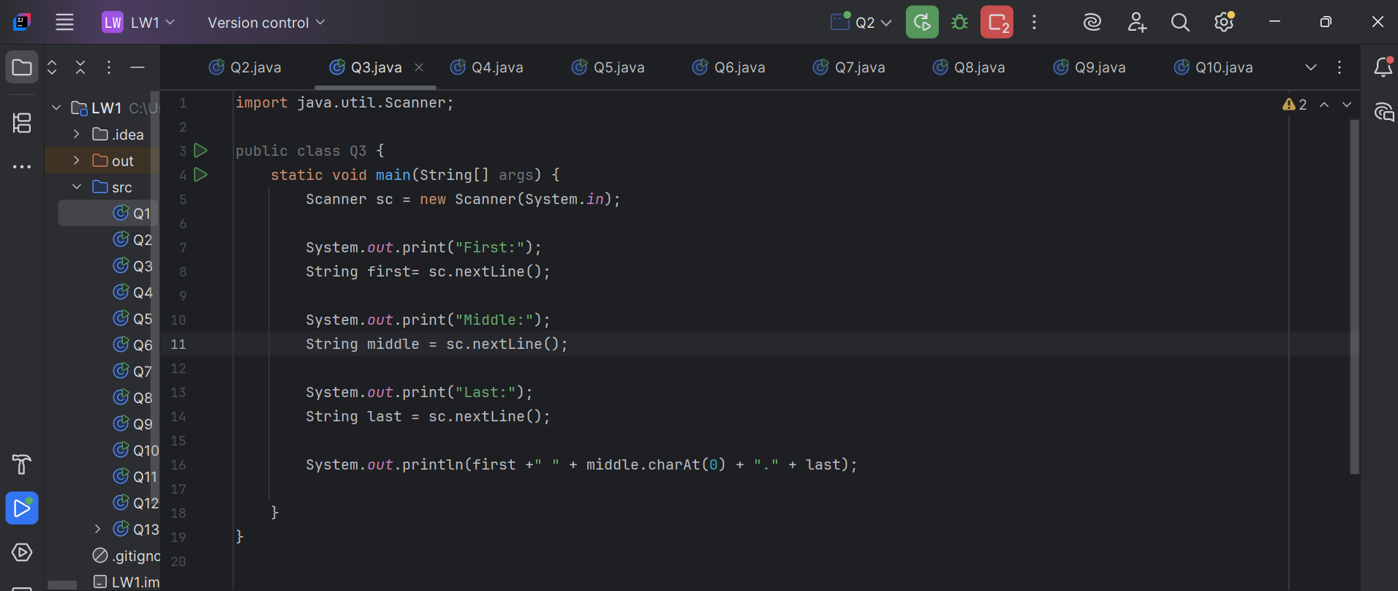

Output :

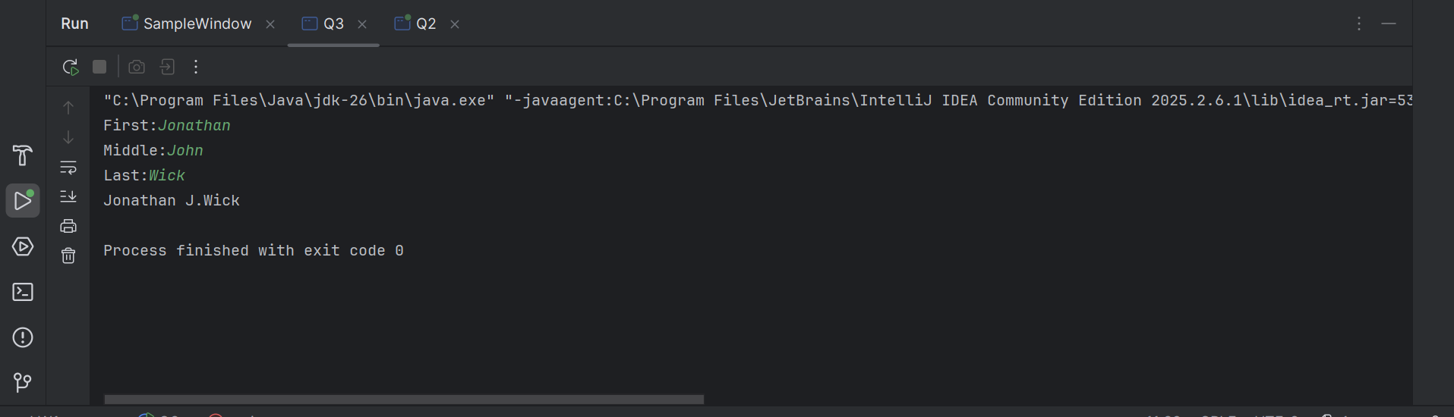

Question 04:

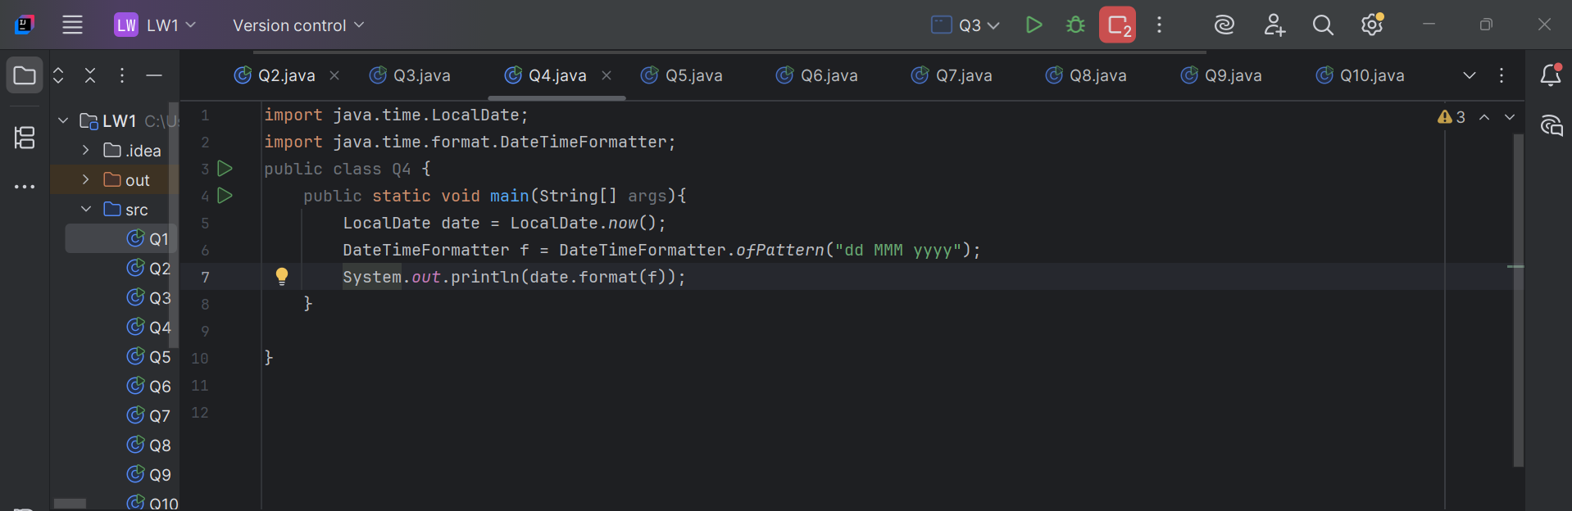

Output :

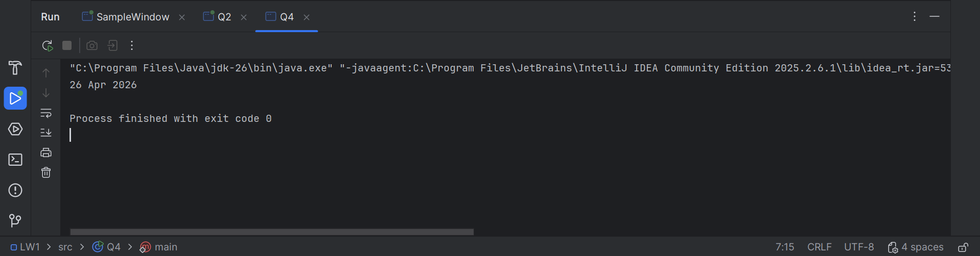

Question 05:

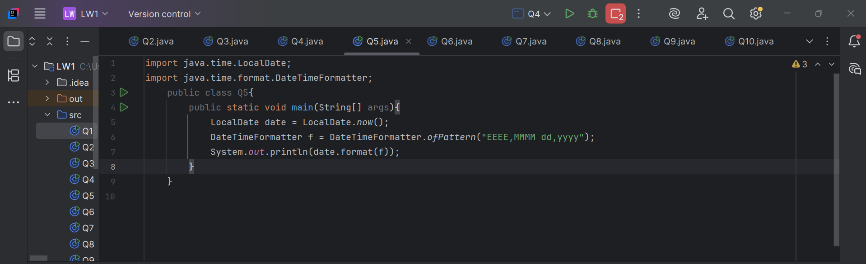
Output :

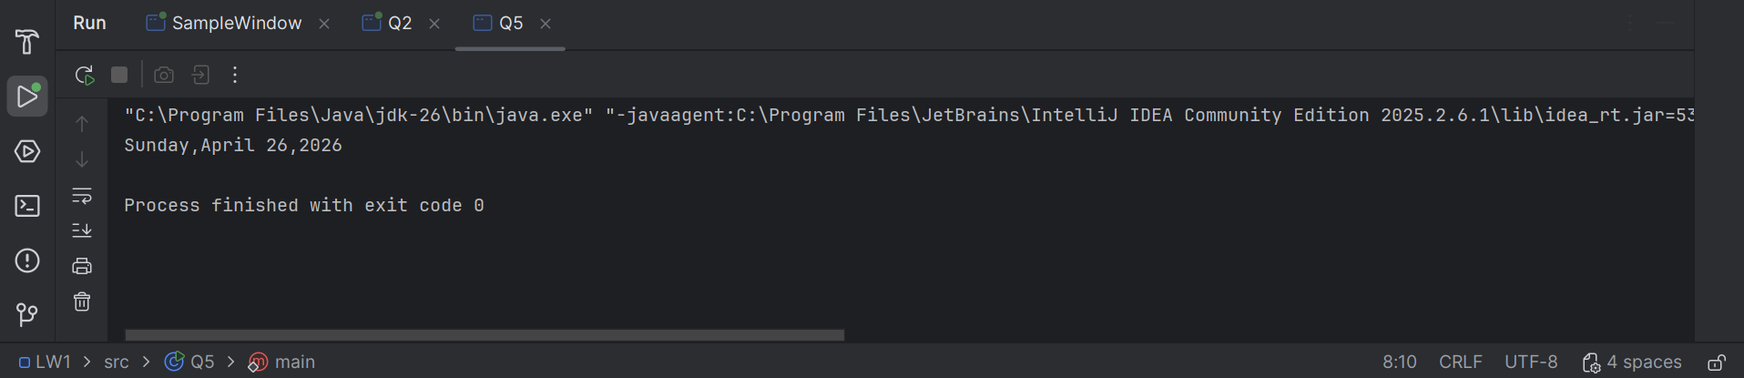

Question 06:

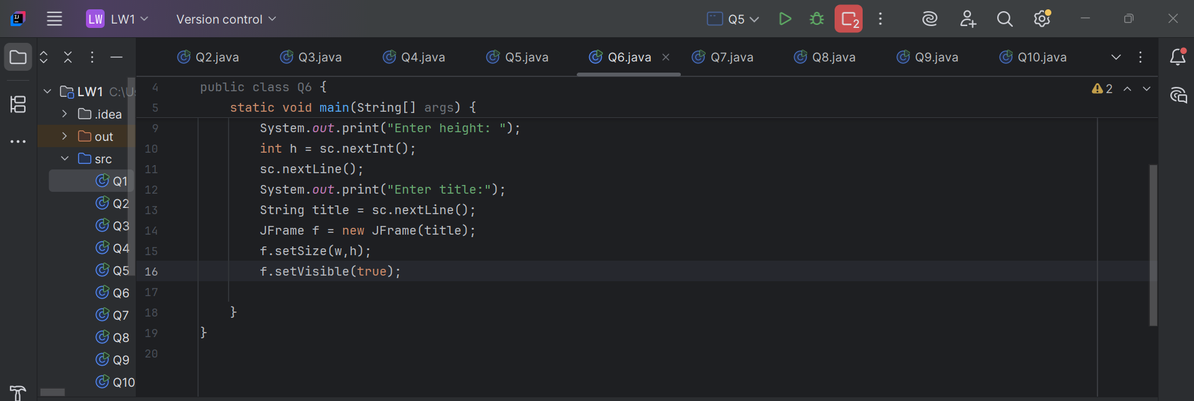

Output :

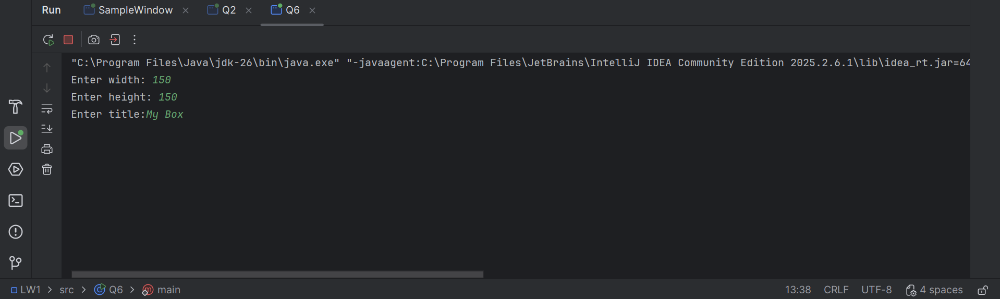
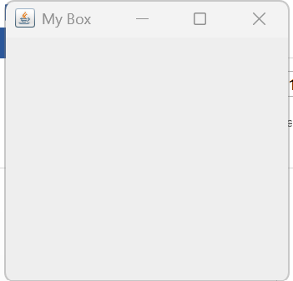

Question 07:

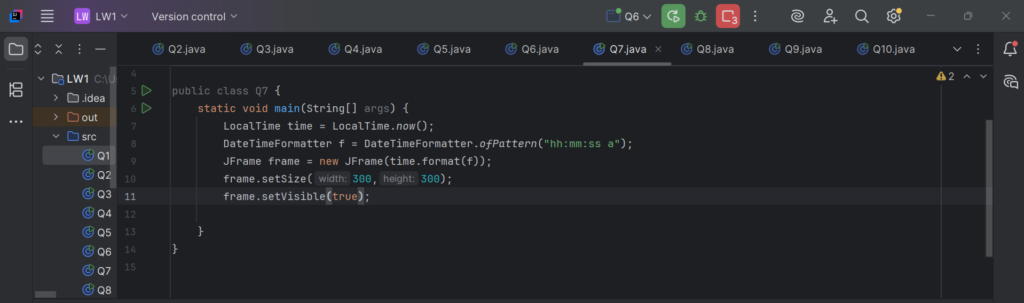

Output :

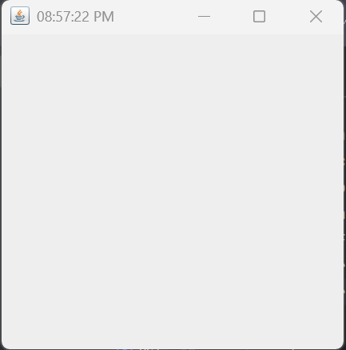
Question 08:

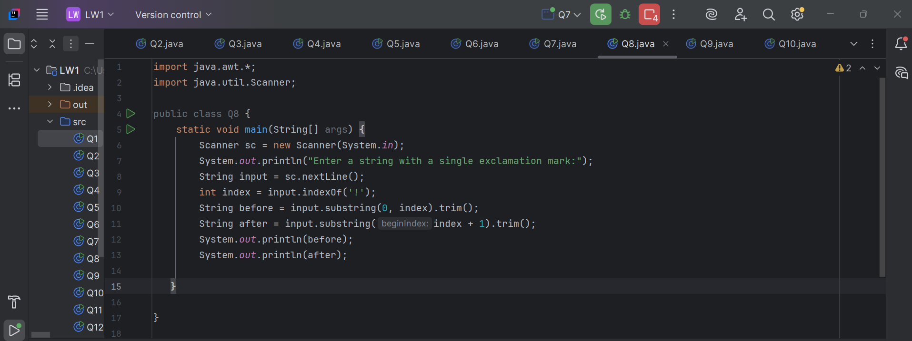
Output :

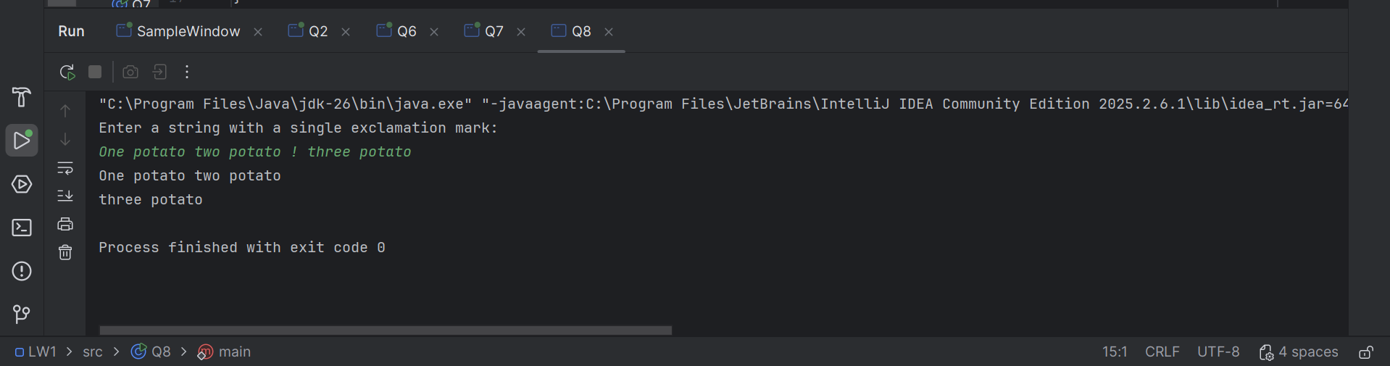

Question 09:

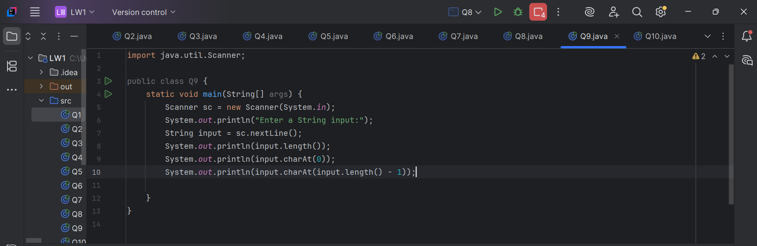
Output :

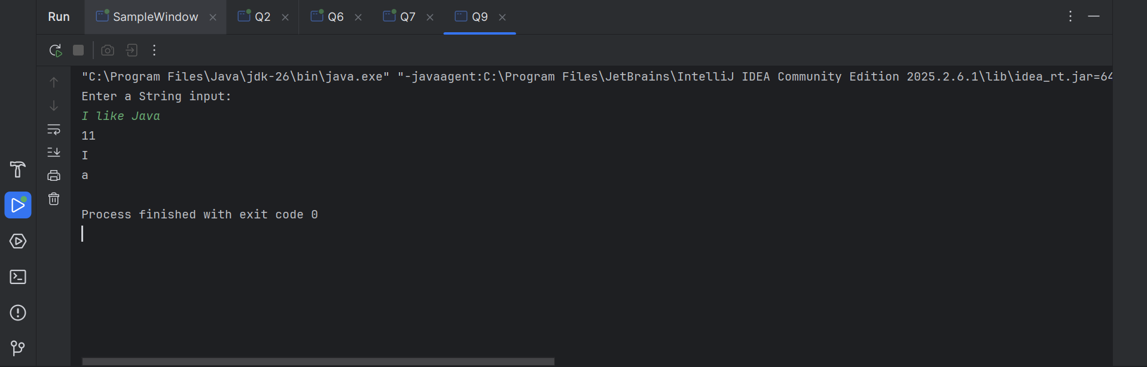

Question 10:

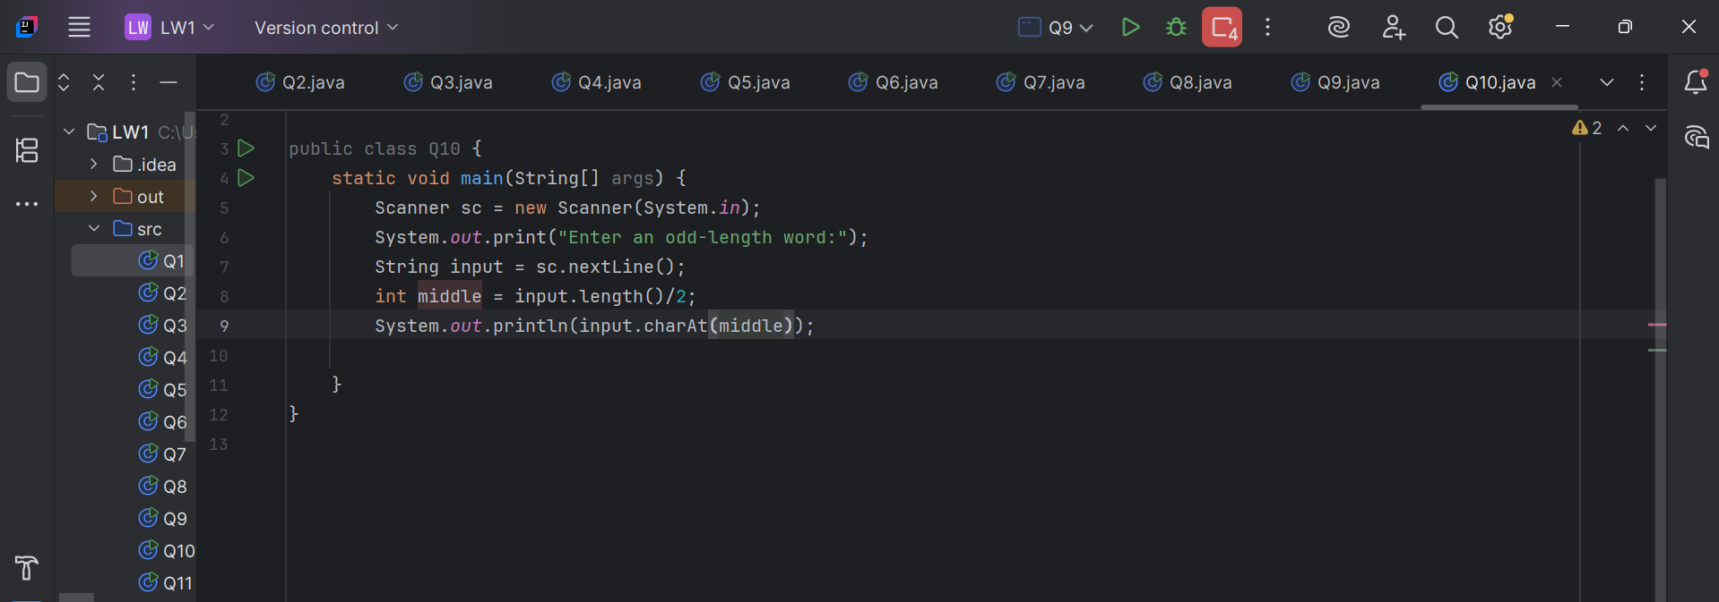

Output :

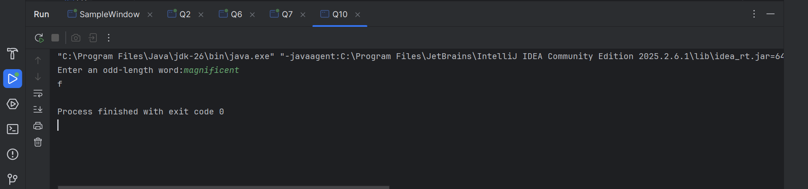

Question 11:

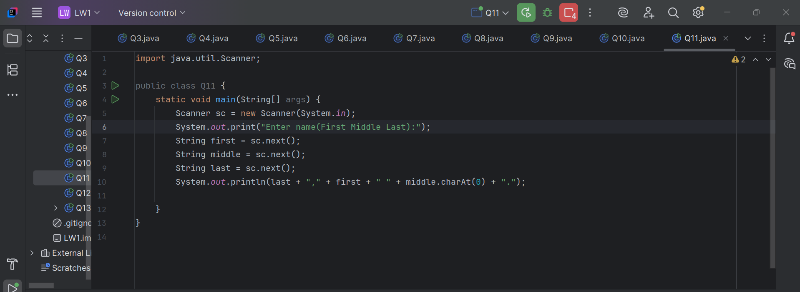

Output :

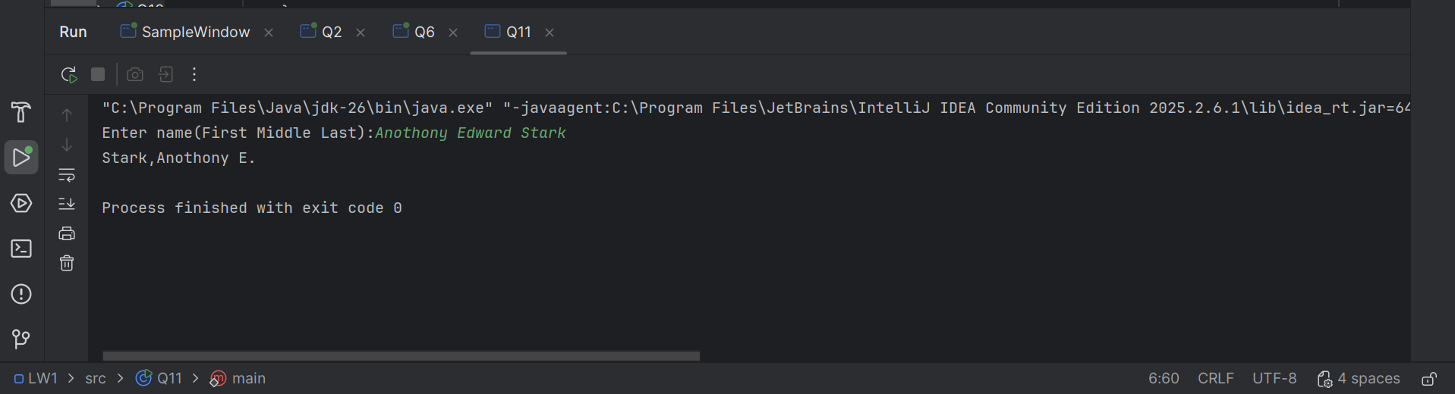

Question 12:
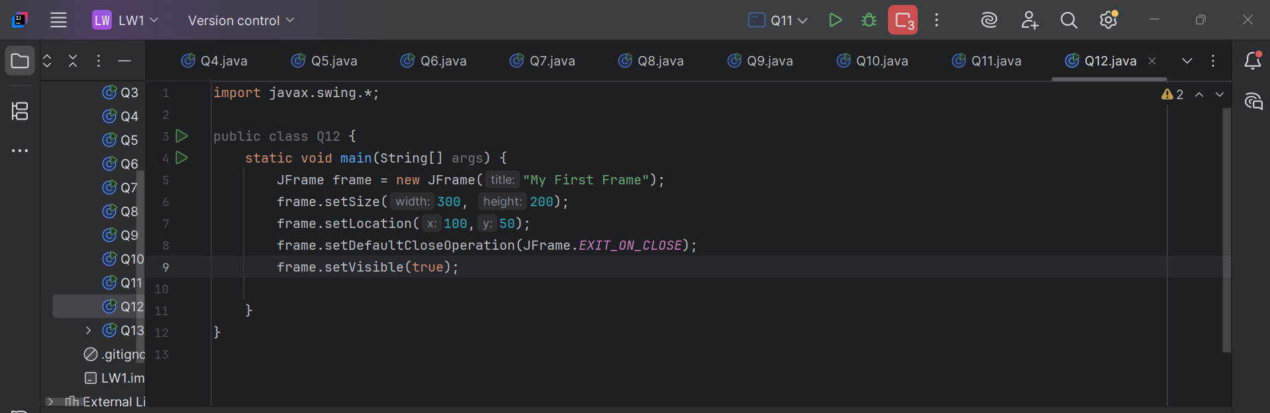
Output :

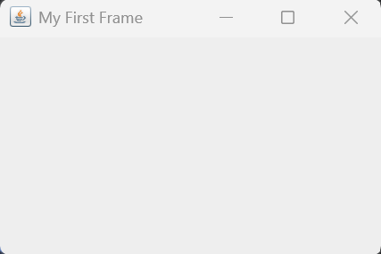
Question 13:

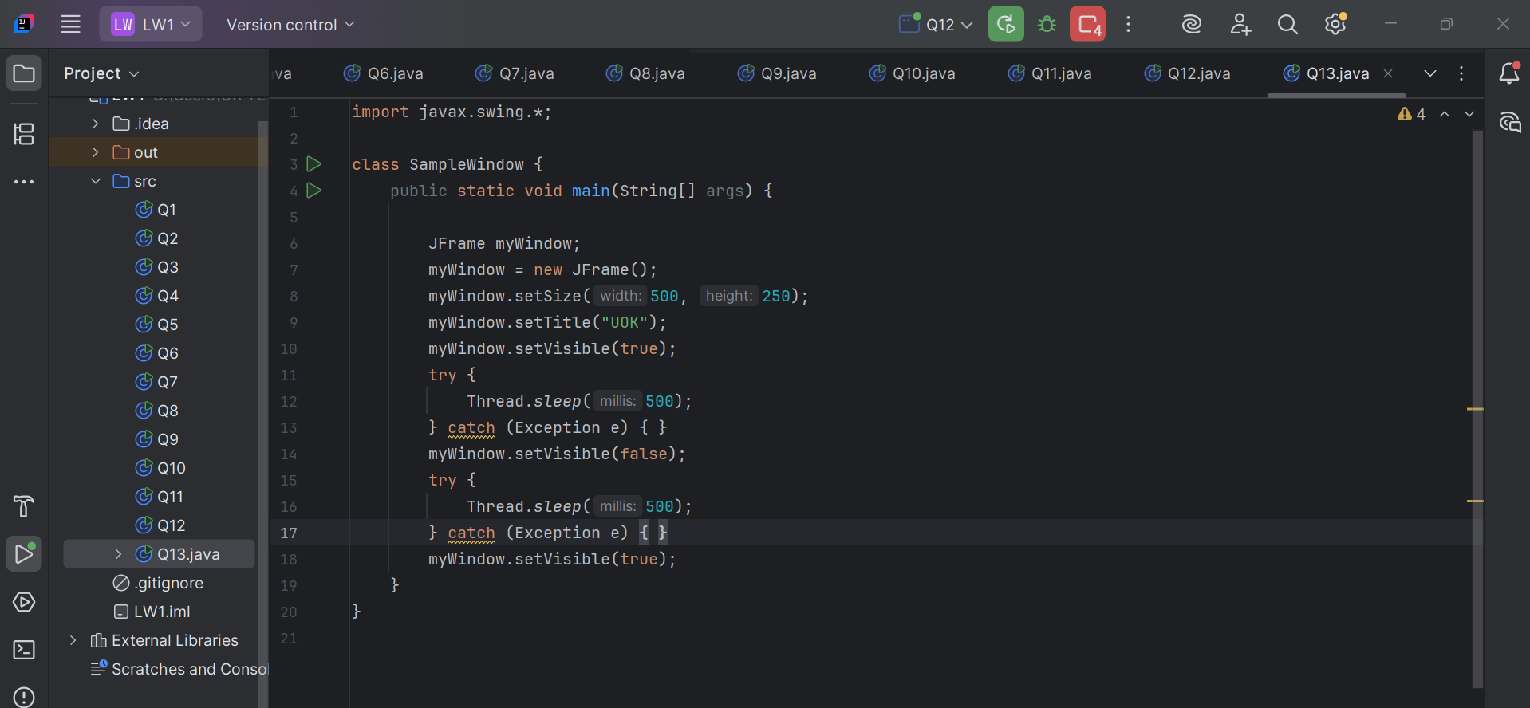
Output :

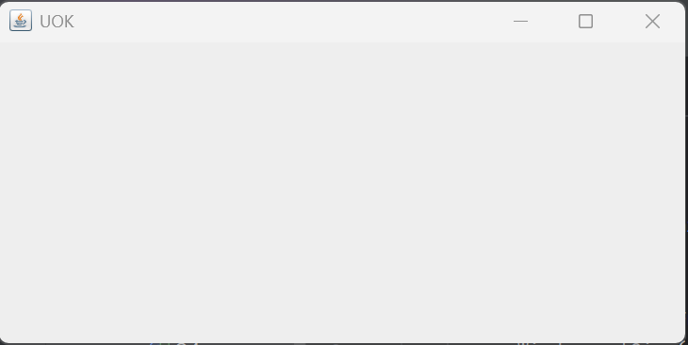

CONCLUSION :

This lab worksheet helped to understand the basic components of Java programming using OOP concepts. We learned how to create GUI applications, take user input, and process data using strings and date/time functions. These skills are important for developing real-world applications.

